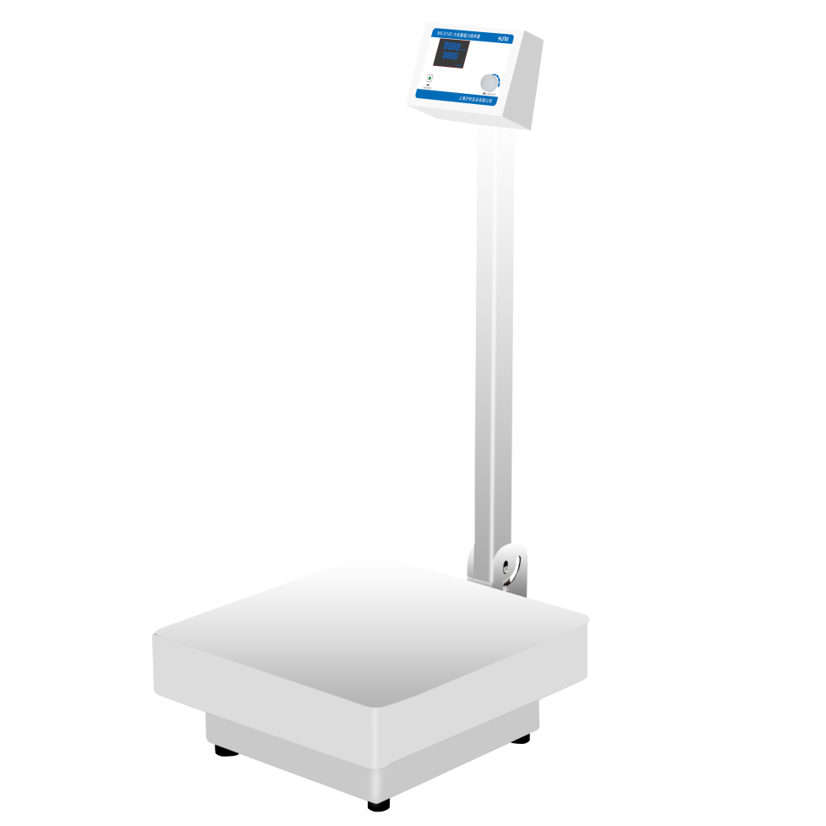

# **MS-D100 Large Capacity Magnetic Stirrer**

**Application：**

MS-D100 Vertical Digital Large Capacity Magnetic Stirrer is mainly used for low viscosity liquid or solid-liquid mixing experiments, especially for the liquid stirring of large sample volume and capacity, and it is also a necessary experimental tool for petroleum, chemical industry, environmental protection, biochemical laboratories, education and scientific research.

**Main Features：**

* Single knob adjustment mode, can set the speed or other operating parameters, convenient and convenient;
* Adopt DC brushless machine drive, microcomputer control, long operation life;
* Standard stirrer 15*100mm, strong magnetic force, good stirring effect;
* LCD liquid crystal display, real-time display speed, convenient to view the experimental data;
* Table top is made of 304 stainless steel, with solid structure and beautiful modelling;
* Run/stop button, in the non-set state, you can start or stop the operation of the instrument;
* The digital display screen is folded, easy to operate and greatly save the experimental space;
* Wide range of sample handling capacity, up to 100L, to meet the experimental needs of large-capacity sample mixing;
* When the equipment malfunctions, the instrument will stop running immediately and display the error code, which greatly improves the safety of the experiment.

**Techncial Parameters：**

|  |  |
| --- | --- |
| Model | MS-D100 |
| Max.Capacity(L) | 100(H2O) |
| Voltage (V) | 220 |
| Working plate material | 304 Stainless steel |
| Motor Type | DC Brushless motor |
| Motor Power(W) | 250 |
| Speed Display | LCD |
| Speed Range(rpm) | 20~1000 |
| Working plate size(mm) | 450*450 |
| Exterior Dimension | 450*480*950 |
| Stirring point qty | 1 |
| Stirring bars size | B type 15*100mm |
| Stirring bars range | 50-180mm |
| Net Weight(kg) | 23 |